**FILES STRUCTURE**

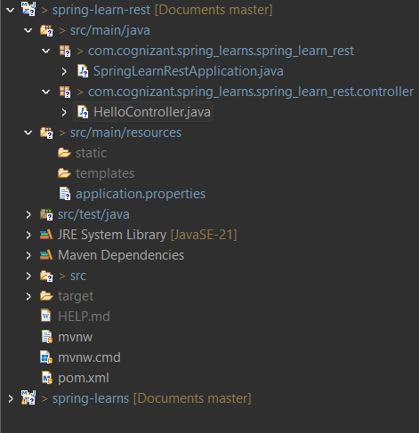

SPRING INTITIALIZER

**HelloController.java**

package com.cognizant.spring_learns.spring_learn_rest.controller;

import org.slf4j.Logger;

import org.slf4j.LoggerFactory;

import org.springframework.web.bind.annotation.GetMapping;

import org.springframework.web.bind.annotation.RestController;

*@RestController*

public class HelloController {

private static final Logger ***LOGGER*** = LoggerFactory.*getLogger*(HelloController.class);

*@GetMapping*("/hello")

public String sayHello() {

***LOGGER***.debug("START");

String message = "Hello World!!";

***LOGGER***.debug("END");

return message;

}

}

**Application.properties**

spring.application.name=spring-learn-rest

server.port=8083

**springLearnRestApplication.java**

package com.cognizant.spring_learns.spring_learn_rest;

import org.springframework.boot.SpringApplication;

import org.springframework.boot.autoconfigure.SpringBootApplication;

*@SpringBootApplication*

public class SpringLearnRestApplication {

public static void main(String[] args) {

SpringApplication.*run*(SpringLearnRestApplication.class, args);

}

}

**AFTER EXECUTION OF PROJECT🡪**

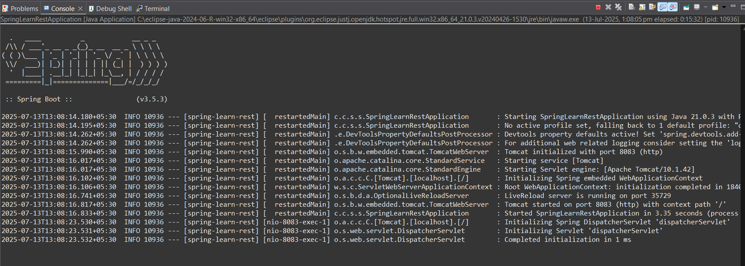

OUTPUT IN LOCALPORT /8083

